‘3D analysis of the influence of specimen dimensions in fretting stresses’

Abstract
In this paper, the contact conditions and stresses during a fretting test have been analysed by means of a three-dimensional finite element model of the contact between a sphere and a flat surface. An h-adaptive process based in elements subdivision has been used in order to obtain a low discretization error at a reasonable computational cost. The influence of finite dimensions of specimen in the stress fields in the contact area and into the specimen has been evaluated. The solution has been compared with classical Cattaneo-Mindlin solution.
Falta el rollo de los resultados******************************************
Key words: fretting; spherical contact; discretization error; h-adaptivity

Introduction
In engineering the term fretting is used to describe the process of damage produced in the interface of two bodies in contact subjected to some small amplitude relative oscillatory slip movement. As a result of such a phenomenon a number of cracks are initiated in the contact zone. These cracks may produce surface degradation by generation and subdivision of small debris or may grow and expand inside one of the bodies eventually producing the fracture of this element. This process appears in many real mechanical systems, such as bolted and riveted joints, shrink fitted shaft connections, blade connections, steel locked coil wire ropes, medical implants, etc.
A number of tests devices where the contact pads (with spherical, cylindrical or flat geometry) slide over the flat surface of the specimen under consideration have been proposed in order to study the fretting problem. According to Hills and Nowell [1] the tests carried out with spherical pads possesses some advantages. Therefore, during the last few years the number of devices developed to carry out this kind of tests has increased.
Figure 1 schematically shows the fretting test analysed in this paper. Two zones of contact are generated on the flat surface of a specimen charged with a constant traction load T by means of the use of spherical fretting pads. First of all, a normal load P is applied over the spherical pads. A tangential load Q that alternatively varies in time follows this normal load. Usually the tangential load Q is lower than μP, so both a slip zone and a stick zone appear in the contact area. The stress field near the contact zone is variable, multiaxial and non-proportional [14] and can lead to the nucleation of a number of microcracks in the surface of the bodies in contact [9].
Various criteria have been proposed during the lasts years ([2],[22] and references foreign, [23]) in order to evaluate initiation and growing of the cracks generated in the contact area. The use of these models requires the evaluation of the stress state in the vicinity of the contact. For spherical contact problems this is usually achieved using analytical or semi analytical methods. The firsts studies related to spherical bodies in contact subjected to normal and tangential loads were carried out independently by Cattaneo [15] and Mindlin [16], [17]. These authors considered the bodies in contact as infinite semi-spaces. Hamilton et al.[8] obtained the stress field inside the bodies loaded with a hertzian distribution of normal and tangential contact pressures on the surface. Hamilton [9] and Sackfield and Hills [24] extended the previous work obtaining a formulation that is easier to process. Using these previous works Domínguez [14] calculated the evolution of the stresses during a fretting fatigue test cycle. As Domínguez shows, the solution obtained is only approximated because finite dimensions of the specimen, tangential contact pressure perpendicular to the tangential load, and some other aspects such as surface wear, surface roughness, etc., are not considered.
Munisamy et al.[3] studied the tangential contact pressure perpendicular to the tangential load Q for sphere-flat contact problems. The effects of finite dimensions of the specimen were studied by Nowell et al. [5] and Fellows et al. [7] in the case of 2D cylinder-flat contact. In the first case the authors evaluated this effect over the contact pressure. In the second paper the internal stress field was obtained.
Figure 1.- Loads applied during a fretting experiment with spherical pads.
The influence of finite dimensions of the specimen in three dimensional spherical contact problems over the stress distribution has been analysed in this paper. The evolution of contact pressure and stress field inside the specimen for different values of specimen width and thickness has been evaluated. A 3D finite element model has been defined in order to achieve this objective. An h-adaptive process of mesh refinement has been developed [13] with the aim of obtaining accurate solutions with a controlled discretization error, and a reasonable computational time. The solution finite element solution has been compared with an analytical solution in order to estimate the degree of approximation of the models.
A number of finite elements models of fretting test have been recently developed. Most of them are bidimensional analyses of cylindrical contact problems. For example, McVeigh and Farris [12] evaluated the influence of the bulk stress applied to the specimen over the contact pressure for this kind of problems. Iyer and Mall [18] used the numerical solution to estimate fretting fatigue life. Tsai and Mall [19] incorporated elastoplastic behaviour in the material in order to obtain the evolution of stress and strains during a fretting fatigue test. In 3D contact problems using spherical pads, Giannakopoulos and Suresh [20] used a bidimensional model and a trigonometrical expansion of the displacement field to simulate the real three dimensional problem. This approximation leads to a reduction in the whole number of degrees of freedom necessary to obtain accurate finite element solutions. Notwithstanding, the effect of specimen width and bulk stress cannot be computed using this expansion.

Finite element model
the geometrical model in figure 2 has been used to obtain the stress distribution in the specimen during a fretting test using spherical fretting pads. The fretting pad consists of a cylinder where the lower face (in contact with the specimen) is a spherical surface. The specimen dimensions L, r and H are chosen to be greater than 10 times the characteristic contact size, therefore they do not have any influence over the stress field near the contact area. The radius of sphere (R), is 50 times bigger than the characteristic contact size, so the error of considering the contact surface as a second order curve is lower than neglecting second order terms in calculus of deformation [21].
Figure 2.- Geometrical model of the fretting test using spherical pad.
The problem has two symmetry planes: the XY plane and the y = -b plane, so the appropriate boundary symmetry conditions have been imposed. Furthermore some restriction over the displacement of nodes located on the shaded surfaces are imposed in order to apply the boundary conditions:
- Load Q is applied to the specimen in surface x = L as a traction stress
- The displacement in X direction of the nodes on surface x = -L is restricted.
- The displacements in directions X, Y and Z of all nodes located on the top surface (y = h) of the spherical pad are forced to be identical to those of the node where the normal load P is applied (co-ordinates x = z = 0 y = h).
By means of these restrictions the transmission of the normal and tangential loads is correctly achieved. As the distance between the top surface and the contact zone is big enough, the applied restrictions do not affect the stress distribution near the contact. The boundary conditions applied minimize the rotation of the spherical pad due to the friction force. The problem of excessive rotation of the pad appears in some finite element models where rigid body motion is avoided connecting soft elements to the fretting pad.
In a first step, the normal load P is applied while displacements in X direction of nodes in line x = z = 0 are restricted in order to avoid rigid body motion. Afterwards these restrictions are eliminated and the tangential load Q is applied. The value of this force should be kept under the value necessary to produce global sliding (Q < μP) so that rigid body motion is prevented. In this second step displacement in X direction of the node located in x = z = 0, y = h is restricted. As the contact problem is non-linear, the loads must be gradually increased in small increments. These load increments must be sufficiently small, otherwise the correct normal and tangential pressure distribution in the contact zone will not be obtained.
The finite element commercial code ABAQUS [10] has been used. This program uses the concept of master surfaces and slaves nodes to define the contact between bodies. The slave nodes are chosen to be those nodes in the specimen that could come in contact with the spherical pad. The master surface has been defined as the spherical surface of the fretting pad. The contact conditions are imposed using the Lagrange multiplier method.
The h-adaptive mesh refinement process used [13] is based on element subdivision. The subdivision process is based on error the error indication given by the Zienkiewicz-Zhu error estimator. Hexahedral elements are considered in the FE model.
The first mesh of the sequence is directly created using the ABAQUS mesh generator, therefore, none of the hexahedral elements are subdivided in the mesh. The computed error for this mesh is used to decide which of the elements should be subdivided to generate the following mesh. The process is repeated until the specified target global error is achieved. Displacement field continuity between adjacent elements with different refinement degree is guarantied using multipoint constraints (MPC’s). A sequence of meshes obtained using this process is shown in Figure 3. In the sequence shown, the global error in energy norm for each mesh is half of the error for the previous mesh.

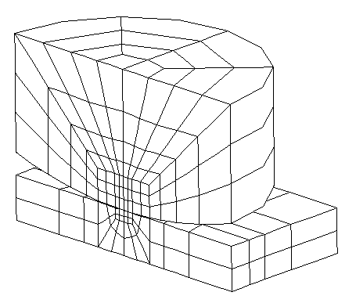  Mesh 1 | 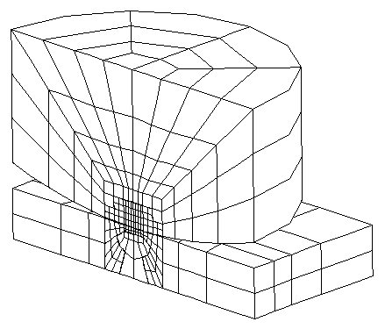  Mesh 2
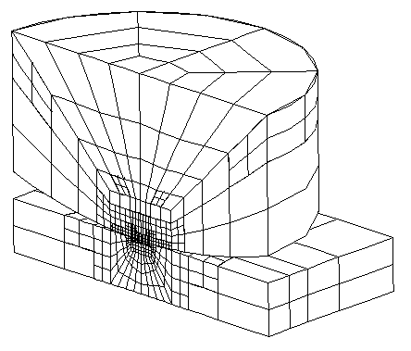  Mesh 3 | 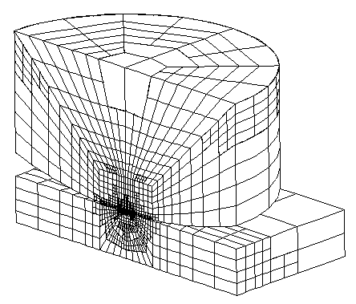  Mesh 4
Figure 3.- H-adaptive mesh refinement sequence. Each mesh reduces a half the indicated error in energy norm,
In all the analysis performed, 20-nodes quadratic element meshes with standard integration in 3x3x3 Gauss points have been used. The elements used in the contact area are 21-nodes special elements REF. A 2% global error in energy norm has been defined as target error for all the analyses performed.
A number of analyses have been carried out for different values of the specimen semi-width b and semi-thickness d. The stress field evolution in the contact zone and inside the specimen has been studied. The sphere dimensions hold the same for all the analysis. The material considered is aluminium Al 7075-T6 with Young modulus E = 71.7 MPa and Poisson ratio ν = 0.33. A Coulomb friction model has been used in the simulation of the contact with a friction coefficient μ = 1.2, which coincides with some experimental data of real fretting tests using spherical pads and the same material ([9],[22]).

Comparison with analytical solution
The comparison of the analytical solutions for the spherical contact problem with the results obtained with the finite element model developed has been used to validate the model.
For comparison purposes dimensions b and d of the specimen were chosen to be greater than 10 times the characteristic contact area size, a∞, in order to consider the specimen as an infinite half space. From now onwards, magnitudes with infinite subindex refer to spherical contact problem between two bodies behaving as infinite half-spaces.
The analytical solution for the contact pressures is based in the work carried out by Cattaneo [15] and Mindlin [16], who studied some spherical contact problems with both, normal and tangential loads. Justification of the following results can be found in [6].
When a normal load P is applied, the pressure distribution in the contact zone, according to Hertz theory, is given by:
$p\left(r\right)=P_{0∞}\sqrt{1−{\left(\frac{r}{a_{∞}}\right)}^{2}}r≤a_{∞}$ Equation 1
where P₀ ∞ is the maximum value of the normal pressure and can be obtained from the following equation:
Equation 2
a∞ is the radius of the contact area which depends on load P and the radius R of the spherical pad:
Equation 3
When a tangential load is applied Q < μP, the contact area is divided into a stick and slip zone. The stick zone is supposed to be circular and its radius can be obtained from the tangential load using
Equation 4
The tangential stress distribution in the contact zone in X direction is given by equation 5
$\begin{aligned}q_{x}\left(r\right)=μp\left(r\right)={μP}_{0_{∞}}\sqrt{1−{\left(\frac{r}{a_{∞}}\right)}^{2}}c_{∞}≤r≤a_{∞} \\ q_{x}\left(r\right)={μP}_{0_{∞}}\left(\sqrt{1−{\left(\frac{r}{a_{∞}}\right)}^{2}}−\frac{c_{∞}}{a_{∞}}\sqrt{1−{\left(\frac{r}{c_{∞}}\right)}^{2}}\right)r≤c_{∞}\end{aligned}$ Equation 5
This is an approximated solution because the slipping (and therefore the shear traction) in direction perpendicular to the applied tangential load (Z direction) has been neglected.
Hamilton and Goodman [8] obtained the stress distribution inside an infinite half-space, Supposing a hertzian contact pressure. This solution has been compared with the finite elements results.
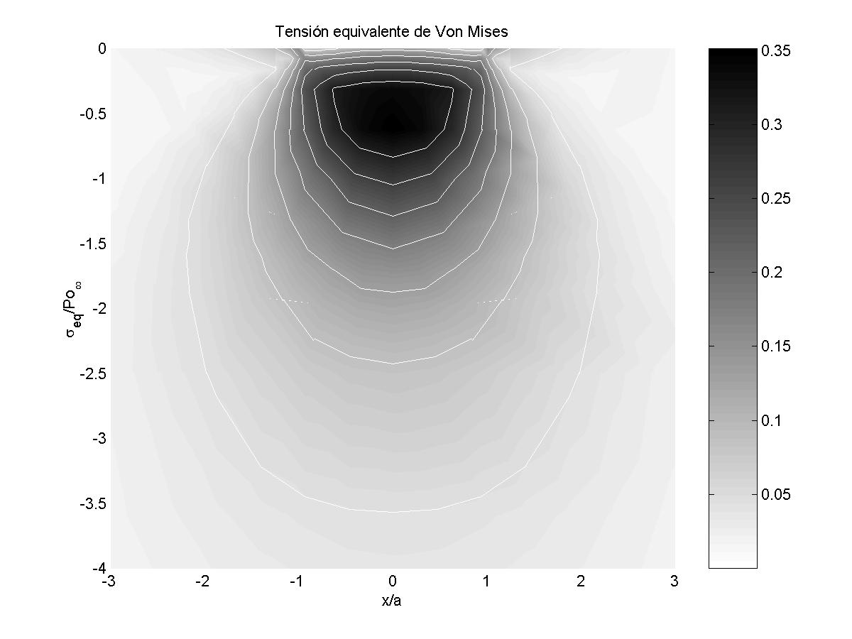  a) | Differences with analytical solution  b)
Figure 4.- Normalized Von Mises stress distribution in the symmetry plane (XY)
of the specimen when only the normal load P is applied.
a)FE solution, b)Differences between FE and analytical solutions
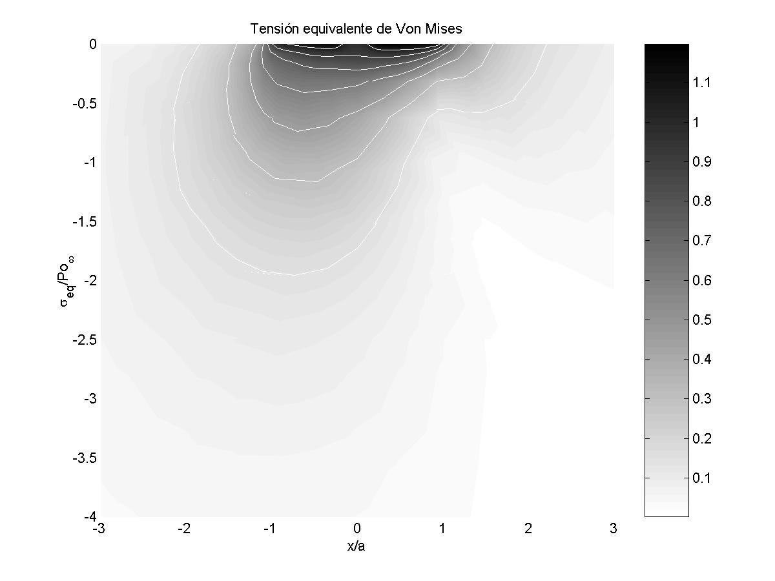  a) | Differences with analytical solution  b)
Figure 5.- Contour plot of the equivalent Von Mises stress in the XY symmetry plane applying normal and tangential loads.
The finite elements results precisely match the analytical solution when only the normal load is applied. Figure 4 shows the Von Mises stress distribution over the XY plane (symmetry plane) for this case. The maximum differences between the two models are about 2 % of the maximum value of equivalent stress. These results are normalised using the maximum contact pressure value P_{0 ∞} (equation 2).
Figure 6 shows the stress distribution σ_{x} along the line y = z = 0 in the vicinity of the contact zone. These finite elements results are compared with the analytical solution and good agreement is observed. Figure 7 shows the distribution of tangential stress τ_{xy} along the same line.
Figure 6.- Normal stress σ_{x} along X axis for different tangential load F values.
Figure 7.- Tangential stress τ_{xy} along X axis for different values of tangential load F.

Differences between the finite elements results and the analytical solution are found in the contact area when tangential stress τ_{yz} are considered. These differences are due to the fact that in the analytical solution the relative slip between the contact surfaces in direction perpendicular to the applied tangential load (Z direction) is considered as negligible compared to those produced in X direction. This is in agreement with the results exposed by Navarro (reference ???) who shows that these stresses are about 5% of P_{0 ∞}. The stress distribution obtained from the finite element model is shown in figure 8. The results shown in this figure correspond to a tangential load Q = 0.9·μ·P (c = 0.8·a) and match those obtained by Munisamy et al. [3] using a numerical method based on influence coefficients. The external circle in Figure 8 shows the theoretical contact zone and the internal circle the theoretical limit between adhesion and slipping zone.
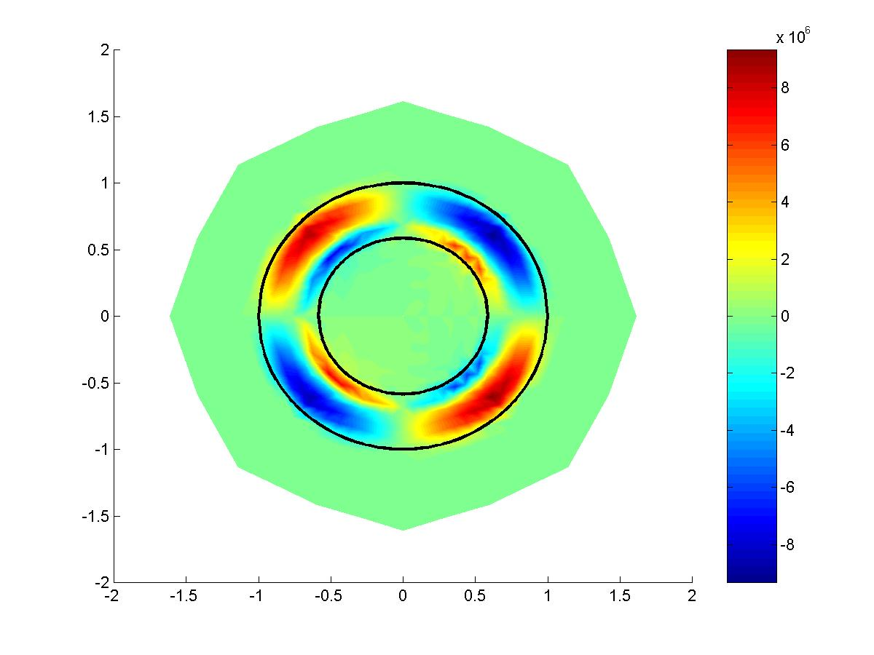
Figure 8.- Tangential stress distribution _{yz} on the contact zone.
The influence of the tangential stress τ_{yz} over the stress distribution inside the specimen has been analysed. The main differences are shown when studying component σ_{z} in the XY plane. It has been found that the equivalent Von Mises stresses obtained by the FE analysis beneath the slip zone are about 3% greater than those predicted by the analytical model due to the differences in σ_{z} (Figure 5).

Normal load
The influence of the specimen dimensions (width and thickness) when only the normal load P is applied has been studied will be shown in this section.
A set of finite elements analyses have been carried out with different values of the specimen thickness (b) keeping the other dimensions (L and d) much greater than the contact area.
When the specimen thickness is reduced, the shape of the contact area remains circular because the problem is still axi-symmetric. However the normal pressure is not of hertzian type and its maximum value increases when the specimen thickness is reduced. For small values of the specimen thickness (approximately lower than 0.2 times the contact size for a infinite half-space, a∞) the maximum value of the contact pressure tends to that obtained for the case of two spheres in contact. In this situation the contact pressure will again be of the hertzian type as shown in Figure 9.
Figure 9.- Contact pressure along X axis for different values of specimen thickness
When the contact pressure is not hertzian, an axisymmetrical distribution of tangential stresses appears on the contact area. The maximum value of these tangential stresses is about 20% of the maximum contact pressure (P_{0 ∞}) for specimen thickness b of about 0.3·a∞.
The normalized maximum normal pressure and maximum tangential contact stress have been plotted in figure 10 for different values of the specimen thickness. The thickness influence becomes important for specimen semi-thickness lower than 2 times the characteristic size of the contact area a∞.
Figure 10.- Maximum normal and tangential pressure versus the specimen thickness.
The error associated to the consideration of hertzian distribution of the normal pressure is not important. Therefore the stress state in the specimen for a given thickness value could be evaluated supposing a hertzian distribution where the values for P₀ and Q₀ are obtained from Figure 10. In such a case, the tangential stresses are neglected.
The variation of the contact size with the specimen thickness is presented in Figure 11. When the thickness is greater than 3 times a∞, the size of the contact area given by the finite element analysis results to be the same as that for an infinite half space. On the opposite site, when the thickness becomes smaller and tends to 0 the size of the contact area approximates to the value for two spheres in contact.

¡Error! Vínculo no válido.
Figure 11.- Size of the contact and adhesion areas versus the specimen thickness.
One of the effects of the specimen thickness reduction is the increase of stresses concentration. The increase of stresses inside the specimen will also produce an increase in the maximum value of the equivalent Von Mises stress. The point where this maximum value is obtained is approximately located at the point x = z = 0, y = -0.5a∞, for specimen thickness b>0.5a∞. For small thickness values this point is located at x = z = 0, y = -b.
Figure 12 shows the effect of the specimen thickness over the evolution of the normalized maximum Von Mises equivalent stress. For thickness values b > 0.5a∞ the maximum value of the equivalent Von Mises stress increases as the thickness is reduced. When the specimen thickness is very small, the stress state inside the specimen approaches to that obtained on the surface of the pads when the contact problem involves two spheres of the same radius. This value has been used in figure 12 to obtain the point for b=0.
¡Error! Vínculo no válido.
Figure 12.-Maximum equivalent Von Mises stress versus the specimen thickness.
The effect of the specimen width (d) over the stress state when only the normal load is applied is very small. Although the problem under consideration is not axisymmetric, the only differences between the finite element model and the analytical solution considering infinite half spaces only appear for specimen width d lower than 1.5·a∞,. An increase of the maximum normal pressure can be observed in this situation. Small tangential stresses in Y direction would also appear, although the differences with the referred analytical solution can be neglected. The contact area becomes elliptical increasing its size along the X direction and decreasing along the Z direction.

Tangential load
The influence of the specimen dimensions b and d over the stress distribution when a tangential load Q < μP is applied has been analysed in this section.
Figure 14.- Contact pressure distribution along X-axis for
different values of specimen thickness. Q = 0.99μP
Figure 14 shows the contact pressure distribution along X-axis when the value of the tangential load is close to produce global sliding of the surfaces in contact.
The contact area (which remains approximately circular) is displaced towards the direction opposite to the applied tangential force as the specimen thickness is reduced.
This displacement is due to the influence of the tangential stress distribution over the displacement of points in the contact area in direction perpendicular to the surface. For very small values of thickness b, the behaviour of the specimen is less compliant than that for the half space. In the limit the thickness b would be 0 and we would have a sphere in contact with a half-space body that would by rigid in the Y direction. The points in the sphere located near II (see figure 15) will not to be in contact with the specimen because of the vertical displacement of the contact surface in the sphere due to the tangential stress distribution. At the same time the normal load around I will be increased as shown in Figure 14. As a result of this ‘stress concentration’ associated to the reduction of the specimen thickness, the point with the maximum value of the Von Mises stress over the surface will move towards I (Figure 15). This can be clearly observed in Figure 16 where the Von Mises stress distribution over the specimen surface are shown for two different values of the specimen thickness. This coupling between normal and tangential stresses over the contact area is similar to that obtained when the problem of two bodies in contact having different elastic properties is studied.
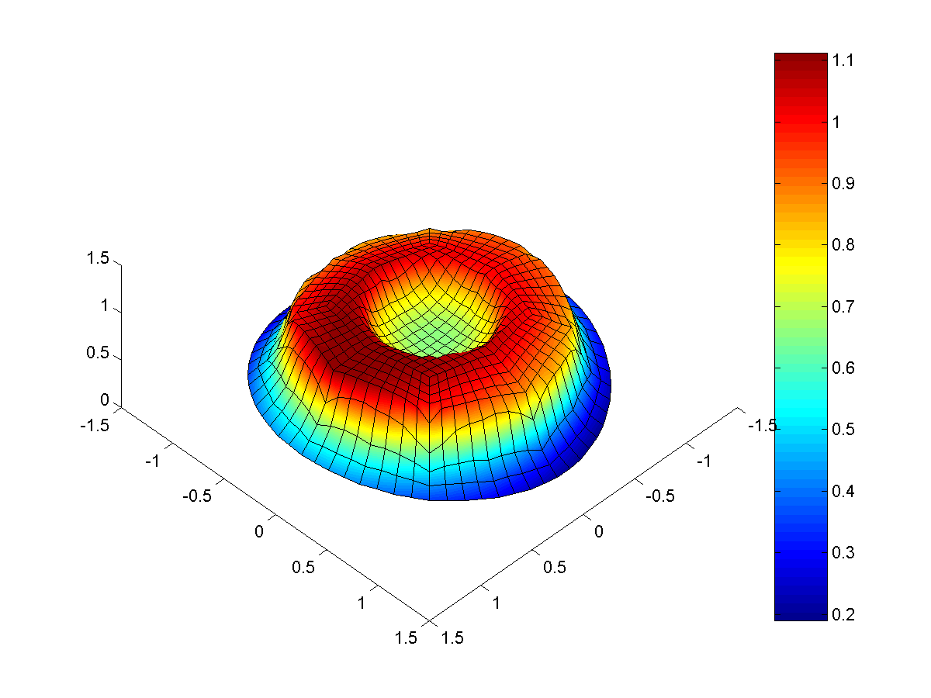  a) | 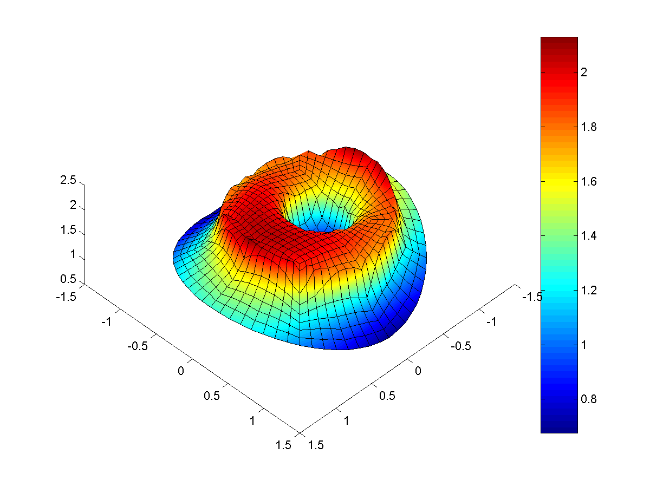  b)
Figure 15.- Equivalent Von Mises stress in the contact area with tangential load Q = 0.9 μ P
a) h=1.25 a∞ b) h=0.2 a∞ .
The shape of the adhesion zone remains approximately circular in all cases. Its size can be evaluated from equation 3 and considering the equivalent reduction of the contact area (Figure 11). If the tangential stresses in the contact area , when only normal load is applied, is negligible with respect to the normal pressure, the adhesion zone will be centred in the contact area. When these tangential stresses are important, the contact area will be displaced as is shown in [Referencia Farris].
¡Error! Vínculo no válido.
Figure 16.- Tangential stress distribution in the contact zone. Tangential load Q = 0.99  P₀.
Comentario y graficas sobre la influencia del espesor. Tengo que poner las graficas que tengo alli en Spanya.

Conclusions
A three-dimensional finite element model of a fretting test with spherical pads has been developed to study the influence of specimen dimensions over the stress field near the contact area. An h-adaptive mesh refinement procedure has been applied to obtain accurate finite element solutions at a reasonable computational cost.
For the case where only a normal load is applied, the reduction of the specimen thickness increases both the maximum contact pressure and the equivalent Von Mises maximum stress inside the specimen. A reduction of the contact size area is also observed. The specimen width has no noticeable effect for values greater than 1.5 the characteristic contact area size.
When the tangential load is applied together with the normal load, the reduction of the specimen thickness produces the displacement of the contact area towards the direction opposite to the applied tangential load. The contact pressure distribution is also modified due to the coupling between normal and tangential stresses produced by the different compliance of the spherical pad and the specimen.
The evolution of the stress field near the contact area, both over the surface and inside the specimen, has been obtained. The analysis carried out showed that even in the case where the specimen and pad dimensions of the finite element model is only 3 times greater than the characteristic contact size, the results obtained precisely match those obtained for the contact of two infinite half spaces in contact. This fact allows for a considerable reduction of the number of degrees of freedom of the finite element model, which is of great importance for three-dimensional contact problems.

Acknowledgements
The authors of this paper want to acknowledge the CICYT for the ….. of this work in the project ……….

Bibliography

- D. A. Hills, A Critical Analysis of Fretting Fatigue Experiments, Fretting Fatigue, ESIS 18, 1994. Mechanical Engineering Publications, London, 171-182
- B. U. Wittkowsky, P. R. Birch, J. Domínguez, S. Suresh, An experimental Investigation of Fretting Fatigue with Spherical Contact in 7075-T6 Aluminium Alloy, Fretting Fatigue: Current Technology and Practices, ASTM, 1999
- R. L. Munisamy, D.A. Hills, D. Nowell. Static Axisymetric Hertzian Contacts Subject to Shearing Forces. Journal of Applied Mechanics. (1994). 61. 278-283
- C. Navarro, J. Dominguez, Contact conditions and stress induced during fretting fatigue, Computational Methods in Contact Mechenics IV, 453-462, 1999.
- D. Nowell, D.A. Hills. Contact Problems Incorporating Elastic Layers. International Journal of Solids and Structures. 24, Nº 1, pp. 105-115, 1988
- D. A. Hills, D. Nowell - (1994) - ‘Mechanics of Fretting Fatigue’
- L.J. Fellows, D. Nowell, D.A. Hills, Contact Stresses in a Moderately Thin Strip (with particular reference ti fretting experiments), Wear 185, 235-238, 1995
- G.M. Hamilton, L. E. Goodman, ‘The Stress Field Created by a Circular Sliding Contact’ – 1966
- G.M. Hamilton, ‘Explicit Equations for the Stresses Beneath a Sliding Spherical Contact’ – 1982
- ABAQUS,
- B. U. Wittkowsky, P. R. Birch, J. Domínguez, S. Suresh, An experimental investigation of fretting fatigue with spherical contact in 7075-T6 aluminium alloy, Fretting fatigue: Current technology and practices, ASTM STP 1367, D. W. Hoeppner, V. Chandrasekaran, C.B. Elliot, Eds. American Society for Testing and Materials, 1999.
- P. A. McVeigh, T.N. Farris, Finite Element Analisys of Fretting Stresses, Journal of Tribology, 119, 797-801, 1997
- J.J. Ródenas, M. Tur, J.E. Tarancón, F. Fuenmayor, H-adaptatividad de Elementos Finitos en Refinamiento por Subdivisión de Malla, Congreso Nacional de Ingeniería Mecánica, 2000
- J. Domínguez, Cyclic varations in friction forces and contact stresses during fretting fatigue, 1998, Wear, 218, pp. 43-53.
- C. Cattaneo, Sul contattc di due corpi elastici: distribuzion locale degli sforzi, Reconditi dell accademia nazionale dei lincei, 1939, 27, 342-348, 434-436, 474-478.
- R.D. Mindlin, H. Deresiewicz, Elastic spheres in contact under varying oblique forces, 1953, Journal of applied mechanics, 75, 327-344.
- R.D. Mindlin, Compliance of elastic bodies in contact, 1949, Journal of applied mechanics, 259-268.
- K. Iyer, Peak contact pressure, cyclicstress amplitudes, contact semi-width and slip amplitude: relative effects on fretting fatigue life, 2001, International journal of fatigue, 23, 193-206.
- C.T. Tsai, Shankar Mall, Elasto-plastic finite element analysis of fretting stresses in pre-stressed strip in contact with cylindrical pad, 2000, Finite elements in analysis and design, 36, 171-187.
- A.E. Giannakopoulos, S. Suresh, A three-dimensional analysis of fretting fatigue, 1997, Acta materalia, 46 (1), 177-192.
- P.J. Torvik, Note on the boundary conditions for contact problems, 1967, Journal of applied mechanics, 34, 761-763.
- V. Lamaq, M.C. Dubourg, L. Vincent, Crack path prediction under fretting fatigue – a theoretical and experimental approach, 1996, Journal of tribology, 118, 711-720.
- C. Petiot, L. Vincent, K. Dang Van, N. Maouche, J. Foulquier, B. Journet, An analysis of fretting-fatigue failure combined with numerical calculations to predict crack nucleation, WEAR 181-183, 1995, 101-111.
- A. Sackfield, D.A. Hills, A note on the Hertz contact problem: a correlation of standard formulae, 1983, Journal of strain analysis, 18 –3 , 195-197.

